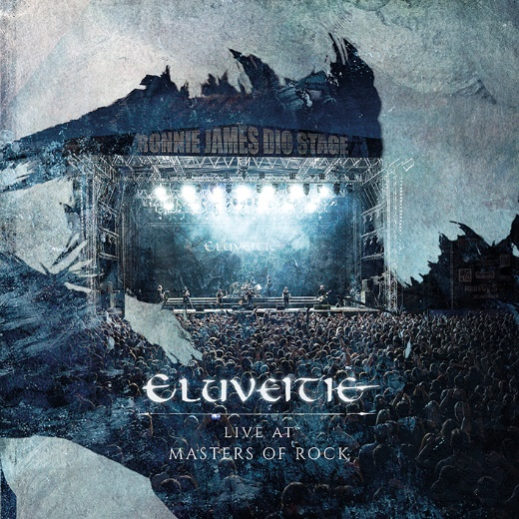

ELUVEITIE
»Live at Masters Of Rock«

OUT: November 1st, 2019

Line-Up: | ELUVEITIE online:  www.riseofthenorthstar.com  www.facebook.com/rotnsoffical  www.nuclearblast.de/riseofthenorthstar
Line-up  Chrigel Glanzmann| Vocals, Whistles, Mandola, Bagpipes, Bodhran  Fabienne Erni| Vocals, Celtic Harp, Mandola  Alain Ackermann| Drums  Rafael Salzmann| Guitars  Jonas Wolf| Guitars  Kay Brem| Bass  Michalina Malisz| Session Hurdy Gurdy  Matteo Sisti| Whistles, Bagpipes, Mandola  Nicole Ansperger| Fiddle | https://de-de.facebook.com/eluveitie  http://eluveitie.ch/news/  https://www.nuclearblast.de/de/label/music/band/about/71068.eluveitie.html
ELUVEITIE are a phenomenon that has been flourishing across the world for more than 15 years. Starting out with their legendary debut album "Spirit" (2006) and the outstanding "Slania" (2008), up to their latest masterpiece "Ategnatos" (2019), the Swiss unit have developed a ground-breaking recipe. As far removed as possible from clichés of drunkenness and silly stories about battles, they have developed a style that turns the best of Folk Metal and Melodic Death into a unique sum. Their great respect for history (which they live out sincerely) mixed with fantastic song writing - results in a sound that hardly anyone can deny the genius of.

The density of hits in their discography is well proven. Particularly apparent during their live shows,
this phenomenon will now be captured on record once more in 2019. "Live At Masters Of Rock" is ELUVEITIE's first live album from their new line-up, containing songs from their current work "Ategnatos". The Swiss Folk Metal institution has once again demonstrated their extraordinary ability to combine stirring music with the mystical and philosophical essence of Celtic mythology, Gallic history, and proto-European culture - into one ground-breaking sound and a memorable performance. The result is a masterly spectacle that leads through the epochal band history like a raging storm, guiding fans and casual viewers alike to immerse themselves deeply in this musical cosmos. Be it songs like "Ategnatos" and "Rebirth" or earlier hits like "Helvetios" or "King" – the implementation is breath-taking. The really big ELUVEITIE hits are not missing from the setlist either, of course: everybody can now enjoy at home, the unbeatable energy that the band brings forth on "The Call Of The Mountains" or "Inis Mona".

"Live At Masters Of Rock" shows once again that ELUVEITIE understand how to seamlessly meld unique elements together that may not usually fit. Especially on stage, the various parts morph together powerfully, in an almost spiritual way. The listener is spoiled with a uniquely clear and punchy sound to a unified undertow. The stormy, even primeval power of Melodic Death meets the wonderful, spiritual soul of Folk Metal. The result is thus - original hits that are based on musical class and choruses that are so beautiful and memorable that they take you right back to the distant past of pre-industrial times. "Live At Masters Of Rock" shows the quintessence of a band whose songs are written for the stage and will last.

